111 Plan—The Innovative Foreign Experts Introduction Plan for National Key Discipline of Agricultural Resources & Environment at Nanjing Agricultural University

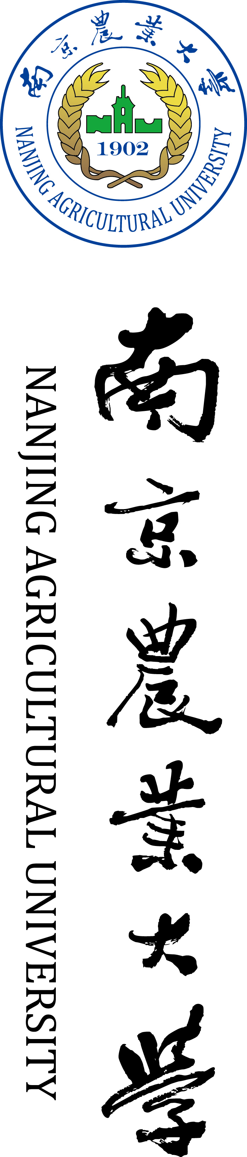

International Workshop on Agricultural Resource Utilization and Soil Quality Improvement
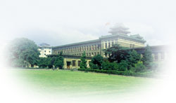
Nanjing Agricultural University, Nanjing, China
December 2 – 4, 2013

主办单位：中华人民共和国教育部
国家外国专家局
承办单位：南京农业大学
国家有机类肥料工程技术研究中心
江苏省有机固体废弃物资源化协同创新中心

Program at a glance

Date | Program | Venue | Conveners
Dec. 2 | Arrival and Registration | Hanyuan Hotel | Jianwen Zou, Jun Zhang, Huijuan Zhang
Dec. 3 - 4 | Workshop (Oral and poster presentations) | The 3rd Floor, Conference Hall on Campus | Qirong Shen, Guohua Xu
Dec. 3 evening | Discussion on academic frontiers  (Chinese participants) | The 6th Floor, Lecture Hall in Hanyuan Hotel | Genxing Pan, Fusuo Zhang
Dec. 5 | Departure | Hanyuan Hotel | Jianwen Zou, Jun Zhang, Huijuan Zhang
Breakfast: the 1st Floor, Hanyuan Hotel; Lunch and dinner: the 3rd Floor, Hanyuan Hotel.

Mobile phone numbers of the conveners:
Jianwen Zou（邹建文） | 159-9629-4639 |  | Jun Zhang （张 军） | 138-5161-9490
Huijuan Zhang（张惠娟） | 138-5176-8194 |  | Genxing Pan（潘根兴） | 136-0517-2931
Qirong Shen（沈其荣） | 139-0158-6468 |  | Fangjie Zhao（赵方杰） | 137-7061-0214
Guohua Xu（徐国华） | 138-0515-5547

Workshop Program (Venue：the 3rd Floor, Conference Hall on Campus)
Date | Time | Opening ceremony Chair：Professor Guohua Xu, Dean of the College of Resources and Environmental Sciences, NAU
Dec. 3 a.m. | 8:30-9:00 | Welcome address by Professor Qirong Shen, Vice President of NAU  Addresses by officials from the National Foreign Expert Bureau and NSFC, P.R. China  Address by Professor James Tiedje, Michigan State University, Fellow of the National Academy of Sciences, USA  Group photograph
Date | Time | Speaker |  | Affiliation | Title of presentation
Dec. 3 a.m. | Session 1: Soil and Global Change Chairs: Genxing Pan, Tony Miller
Dec. 3 a.m. | 9:00-9:30 | Yakov Kozayakov |  | University Goettinggen, Germany | Effects of elevated CO₂ on soil processes
Dec. 3 a.m. | 9:30-10:00 | David Wolfe |  | Cornell University, USA | Soil health management for climate change resilience and mitigation
Dec. 3 a.m. | 10:00-10:30 | Bob Rees |  | Scotish Rural College, UK | Intensification of agriculture in tackling climate change
Dec. 3 a.m. | 10:30-10:45 | Tea break
Dec. 3 a.m. | 10:45-11:15 | Evan Siemann |  | Rice University, USA | Invasive plants in global changing world
Dec. 3 a.m. | 11:15-11:45 | Zhengqin Xiong |  | Nanjing Agricultural University, China | Net global warming potentials of intensively managed vegetable ecosystems and rice-wheat rotations in China
Dec. 3 a.m. | 11:45-12:15 | Kun Cheng |  | Nanjing Agricultural University, China | Climate change mitigation potential of China's cropland
Workshop Program (Venue：the 3rd Floor, Conference Hall on Campus)
Dec. 3 p.m. | 12:15-13:00 | Lunch (the 3rd floor, Hanyuan Hotel)
Dec. 3 p.m. | 13:00-14:00 | Poster session (the 3rd Floor, Conference Hall on Campus)
Dec. 3 p.m. | Session 2: Managing Nutrients & Contaminants Chairs: Jianwen Zou, David Wolfe
Dec. 3 p.m. | 14:00-14:30 | Fusuo Zhang | China Agricultural University, China |  | New paradigm of nutrient management to ensure both food security and environmental quality
Dec. 3 p.m. | 14:30-15:00 | David Crowley | University of California, Riverside, USA |  | Artificial neural network models for prediction of relationships between microbial community structures and soil management practices
Dec. 3 p.m. | 15:00-15:30 | Wenju Liu | Agricultural University of Hebei, China |  | Si effect on As behaviors in the system of soil-plants grown in soil contaminated by arsenic, lead and zinc
Dec. 3 p.m. | 15:30-15:45 | Tea break
Dec. 3 p.m. | 15:45-16:15 | Hans Lambers | University of Western Australia, Australia |  | A comparison of the significance of cluster roots in old P-impoverished and in young P-abundant soils
Dec. 3 p.m. | 16:15-16:45 | Chaofeng Huang | Nanjing Agricultural University, China |  | Molecular mechanisms of aluminum resistance in higher plants
Dec. 3 p.m. | 16:45-17:15 | Enzo Lombi | University of South Australia, Australia |  | Development and application of synchrotron-based techniques for the investigation of trace elements in plants
Dec. 3 p.m. | 17:15-17:45 | Min Zhang | Shandong Agricultural University  , China |  | Industrialization progress and application of slow & controlled release fertilizers in China
Dec. 3 evening | 18:00-19:30 | Banquet (the 3rd floor, Hanyuan Hotel)
Dec. 3 evening | 20:00-22:00 | Discussion on academic frontiers (Chinese participants, Lecture Hall, the 6th Floor, Hanyuan Hotel)  Chairs：Genxing Pan, Fusuo Zhang

Workshop Program (Venue：the 3rd Floor, Conference Hall on Campus)
Date | Time | Speaker | Affiliation | Title of presentation
Dec. 4 a.m. | Session 3: Soil Microbiology and Ecology Chairs: Qirong Shen, Yoram Kapulnik
Dec. 4 a.m. | 8:30-9:00 | James M. Tiedje | Michigan State University, USA | Omics of the rhizosphere
Dec. 4 a.m. | 9:00-9:30 | Ruifu Zhang | Nanjing Agricultural University, China | Management to Enhence Root Colonization of Beneficial Rhizobacteria
Dec. 4 a.m. | 9:30-10:00 | Manqiang Liu | Nanjing Agricultural University, China | Earthworms promote both N₂O emissions and vegetable yield: A field study with different manure placement and earthworm ecological strategy
Dec. 4 a.m. | 10:00-10:15 | Tea break
Dec. 4 a.m. | 10:15-10:45 | Shixue Yin | Yangzhou University, China | What is a healthy/diseased soil/soil fungal community from microbial network perspectives?
Dec. 4 a.m. | 10:45-11:15 | Qiang Chen | Sichuan Agricultural University, China | Physicochemical and microbial properties in the process of biochemical humic acid produced by straw fermentation
Dec. 4 a.m. | 11:15-11:45 | Huizhen Qiu | Gansu Agricultural University, China | Effects of continuous monocropping on microbial diversity in potato rhizosphere in Gansu province

Workshop Program (Venue：the 3rd Floor, Conference Hall on Campus)
Dec. 4 p.m. | 11:45-13:30 | Lunch (the 3rd floor, Hanyuan Hotel)
Dec. 4 p.m. | Session 4: Nutrient Use Efficiency Chairs: Fangjie Zhao, Hans Lambers
Dec. 4 p.m. | 14:00-14:30 | Tony Miller | John Inners Centre, UK | The root/soil interface and nitrogen acquisition
Dec. 4 p.m. | 14:30-15:00 | Yoram Kapulnik | National Academy of Agricultural Sciences, Israel | Comparative analysis of strigolactones analogs activity in plants
Dec. 4 p.m. | 15:00-15:30 | Leon Kochian | Cornell University, USA | Building a molecular toolbox for improving cereal crop adaptation to acid soils
Dec. 4 p.m. | 15:30-15:45 | Tea break
Dec. 4 p.m. | 15:45-16:15 | Hinanit Koltai | National Academy of Agricultural Sciences, Israel | Strigolactones are associated with plant response to nutrient conditions
Dec. 4 p.m. | 16:15-16:45 | Wenfeng Tan | Central China Agricultural University  ,China | Protein complexation with humic acid - A model case study
Dec. 4 p.m. | 16:45-17:15 | Mian Gu | Nanjing Agricultural University, China | Engineering phosphorus efficient plants
Dec. 4 p.m. | 17:15-17:45 | Yajun Gao | Northwest A&F University, China | Effects of summer green manure on winter wheat growth and soil quality in dryland of Loess Plateau
Dec. 4 p.m. | Closing ceremony Chair: Qirong Shen
Dec. 4 p.m. | 18:00 | Dinner (the 3rd floor, Hanyuan Hotel)

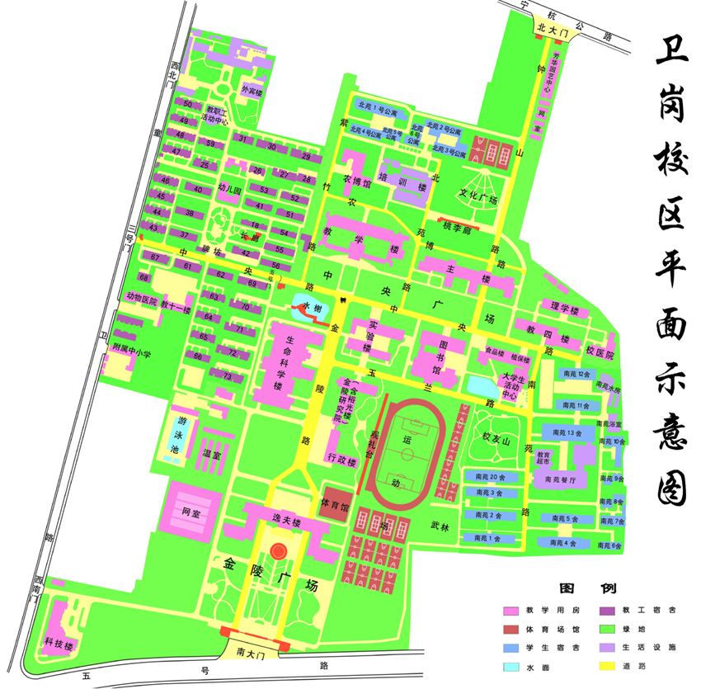
Campus Map
Conference Hall
Hanyuan Hotel

